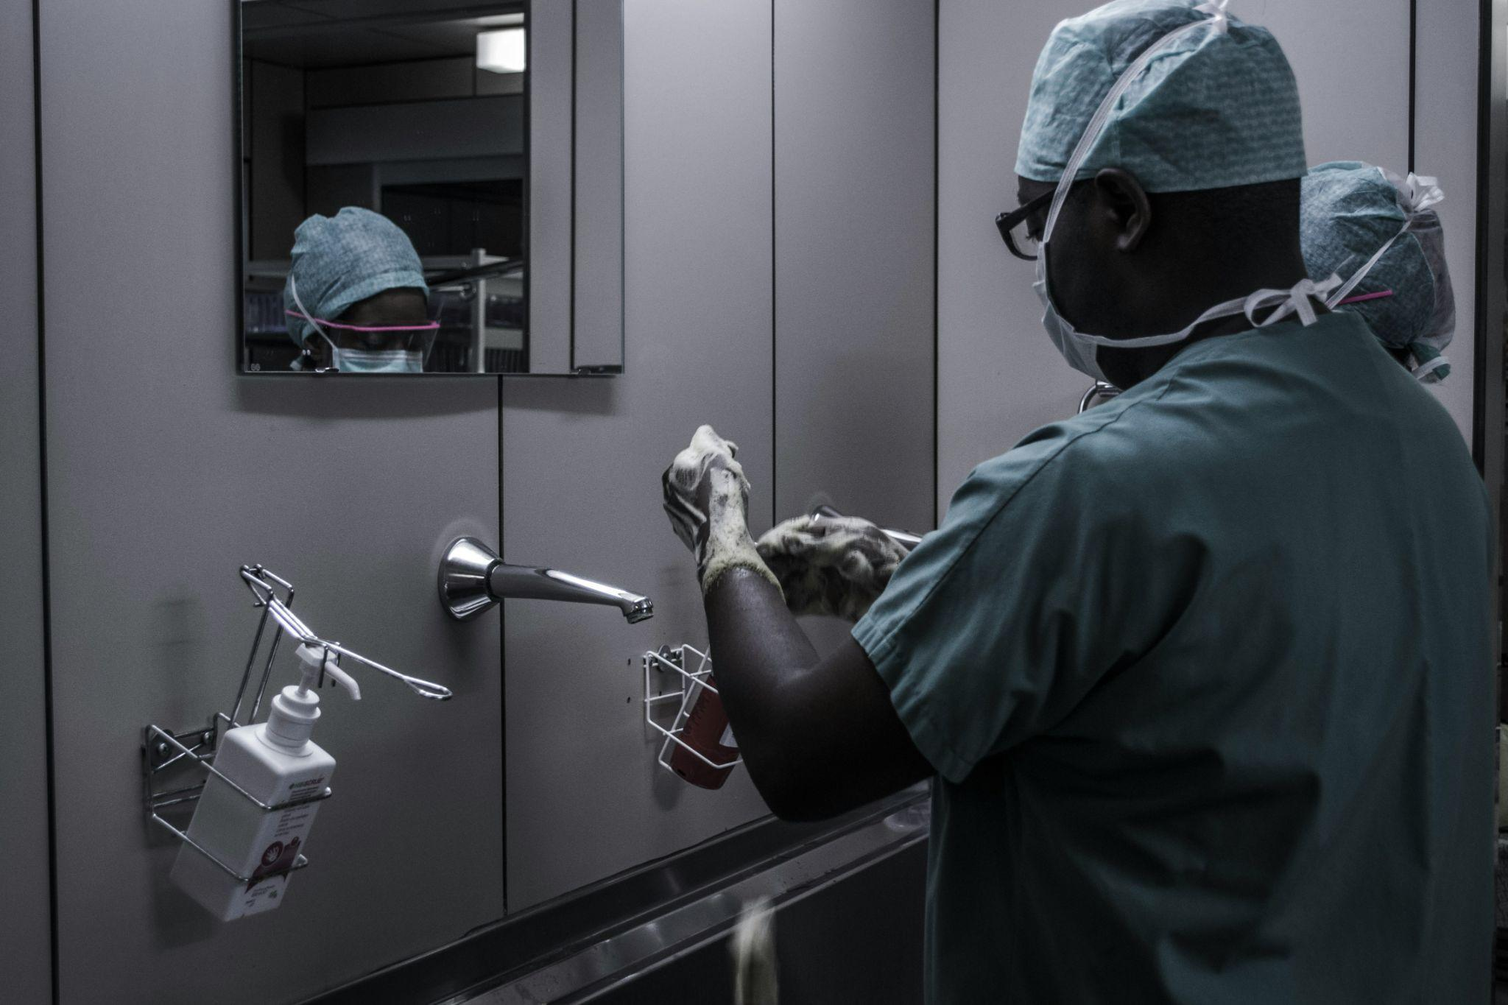

HealthHub Connect Project

# Group members:

1.Hope Wanjiru

2.Elvis Njuki

3.Paul Karanja

# Problem and Solution:

The HealthHub Connect Project aims to address the challenge of fragmented health information systems in Kenya by providing a comprehensive hospital-based software solution. Currently, hospitals often struggle with disconnected databases and inefficient communication channels, leading to delays in patient care and administrative inefficiencies. The software solution proposed under the HealthHub Connect Project offers a centralized platform for managing patient records, scheduling appointments, tracking medical inventory, and facilitating communication between healthcare providers. By streamlining these processes, the software promises to enhance the overall efficiency and effectiveness of healthcare delivery in Kenya.

# Target Users:

The primary users of the HealthHub Connect Project include healthcare professionals such as doctors, nurses, and administrative staff working within hospitals. Additionally, patients will also interact with the system to access their medical records, schedule appointments, and communicate with their healthcare providers. Furthermore, health policymakers and administrators may utilize the system to gather data and insights for decision-making purposes. By catering to these diverse user groups, the HealthHub Connect Project aims to improve collaboration and communication across the healthcare ecosystem.

# Project Scope:

The scope of the proposed database system project encompasses various aspects of hospital management and patient care. Specifically, the project will focus on developing modules for electronic health records (EHR), appointment scheduling, inventory management, and communication tools. These components will automate routine tasks, such as updating patient information, managing medical supplies, and coordinating appointments, thereby freeing up time for healthcare professionals to focus on delivering quality care. However, certain tasks, such as clinical diagnosis and treatment decisions, will still require human judgment and expertise.

# Why This Project Matters:

Implementing the HealthHub Connect Project as a database system solution for CMT 109 would be highly beneficial for several reasons. Firstly, it aligns with the course's objectives of developing practical skills in database design and implementation. Students will gain hands-on experience in building a real-world healthcare information system, which is a valuable skill in today's digital era. Moreover, the project addresses a critical need within the healthcare sector by improving data management and communication processes. By demonstrating the project's efficiency and effectiveness, CMT 109 can contribute to the broader goal of enhancing healthcare delivery not only within individual hospitals but also across the entire healthcare network in Kenya. Through interoperability and data sharing features, the HealthHub Connect Project has the potential to connect hospitals nationwide, enabling seamless collaboration and improving patient outcomes on a larger scale. Thus, investing in this database system project would not only benefit students academically but also make a significant impact on the healthcare landscape in Kenya.

Page break image